1. We need to solve for the expected value and variance of $\underline{x_{n}}$ using the knowledge that $E(x_{i})=μ and V(x_{i})=σ^{2}$. $E(\underline{x_{n}})=\sum_{i=1}^{n}{}\frac{x_{i}}{n}=\frac{nμ}{n}=μ$, $V(\underline{x_{n}})=V(\sum_{i=1}^{n}{}\frac{x_{i}}{n})=\frac{1}{n^{2}}\sum_{i=1}^{n}{}{V(x}_{i})=\frac{nσ^{2}}{n^{2}}=\frac{σ^{2}}{n}$. Using this we can now work forwarded from the provided inequality, $P(|Y-E(Y)|≥t)≤\frac{V(Y)}{t^{2}}→P(|\underline{x_{n}}-μ|≥kσ)≤(\frac{σ^{2}}{n})(\frac{1}{kσ})^{2}$ $→P(|\underline{x_{n}}-μ|≥kσ)≤\frac{1}{nk^{2}}→1-P(|\underline{x_{n}}-μ|≥kσ)>1-\frac{1}{nk^{2}}→P(|\underline{x_{n}}-μ|<kσ)>1-\frac{1}{nk^{2}}$. We now need to show the best way to choose n so that the probability is at least $1-α for 0<α<1$. $1-α≤(1-\frac{1}{nk^{2}})→α≥\frac{1}{nk^{2}}→nk^{2}≥\frac{1}{α}→n≥\frac{1}{αk^{2}}$.
2. 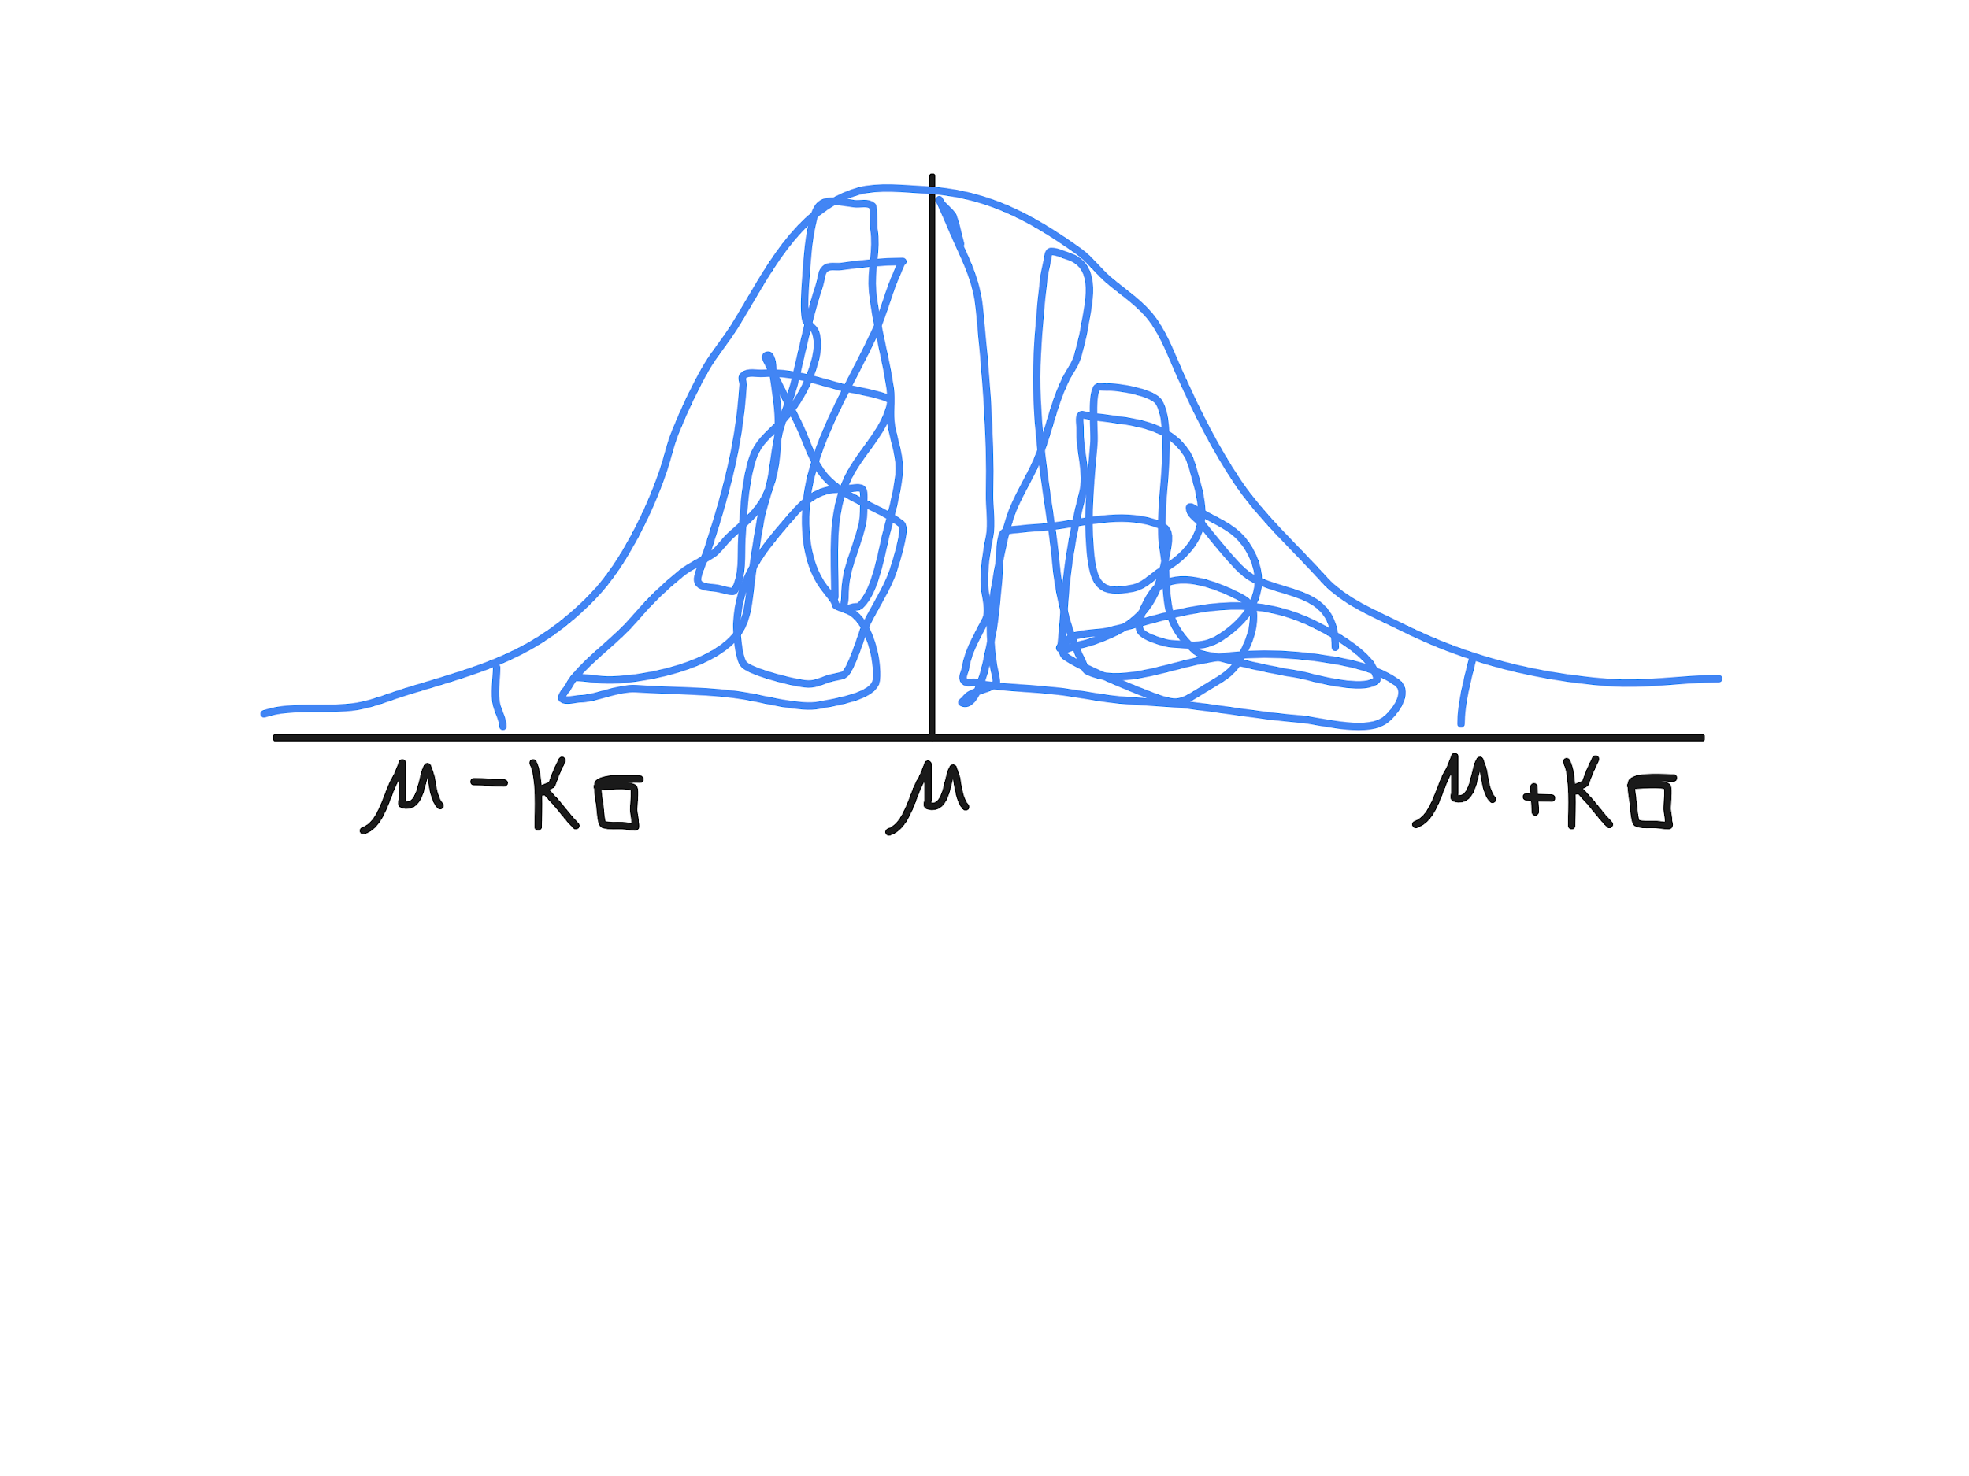
3. Based on the graph in (b) we know that $P(μ-kσ<\underline{x_{n}}<μ+kσ)→P(-kσ<\underline{x_{n}}-μ<kσ)→P(\frac{-kσ}{\frac{σ}{\sqrt{n}}}<\frac{\underline{x_{n}}-μ}{\frac{σ}{\sqrt{n}}}<\frac{kσ}{\frac{σ}{\sqrt{n}}})→$ $P(-k\sqrt{n}<z<k\sqrt{n})$ where z is a normally distributed random variable between 0 and 1. Given this the previous probability is greater than or equal to. $Φ(k\sqrt{n})-Φ(-k\sqrt{n})=Φ(k\sqrt{n})-(1-Φ(k\sqrt{n}))=2Φ(k\sqrt{n})-1$. So we get the required inequality of $P(|\underline{x_{n}}-μ|<kσ)≥2Φ(k\sqrt{n})-1$.
4. $1-α≤2Φ(k\sqrt{n})-1→1-\frac{α}{2}≤Φ(k\sqrt{n})→Φ^{-1}(1-\frac{α}{2})≤k\sqrt{n}→\frac{Φ^{-1}(1-\frac{α}{2})}{k}≤\sqrt{n}$ $→(\frac{Φ^{-1}(1-\frac{α}{2})}{k})^{2}≤n$.

|  |  |  |
| --- | --- | --- |
| $α$ | $\frac{1}{α}$ | $(Φ^{-1}(1-\frac{α}{2}))^{2}$ |
| 0.1 | 10 | 2.7 |
| 0.05 | 20 | 3.8 |
| 0.01 | 100 | 6.6 |
| 0.005 | 200 | 7.9 |
| 0.001 | 1000 | 10.5 |

1. It is very conservative because given a certain alpha value the Chebyshev Inequality uses way more samples than a normal distribution.